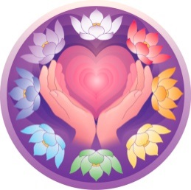
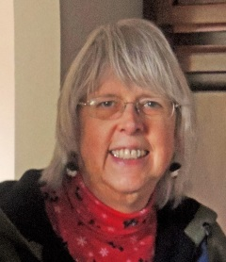
Penny Burdick, MD, HTCP/I
Mandala Healing Touch
NEWSLETTER
Winter, 2015
In the cold and damp of winter on the north Olympic Peninsula, I send a bit of light and warmth to all of you in this, my FIRST quarterly newsletter. In these letters, my plan is to share some insight about life, favorite quotes, and suggestions for staying healthy in mind, body and spirit. Input from YOU, my readers, is always welcome.
Now that the hurry and excitement of the holiday season are past, it seems a good time to turn inward and focus on a little self-care, and nurturing our relationships.
In practicing energy healing work, we talk about the importance of connecting, balancing and clearing the energy field to promote healing for our clients. I believe these same terms can be applied to our personal relationships, as well.

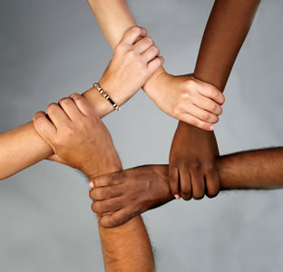
CONNECT
How strong is your connection to the people most important in your life?
By offering love, compassion and support to one another, the bonds between us become stronger, and we are better able to support one
another in times of need.
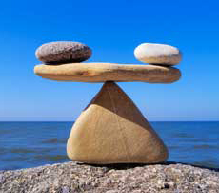
BALANCE
Relationships are strongest when most balanced. Allowing mutual learning, loving, and serving is key. When we relate as equals, and truly listen to one another without judgment or interruption, our personal balance also grows.


CLEAR
When we breathe slowly & deeply, then consciously release our anger, blame, resentment and negative judgment of those around us, we make room in our hearts for acceptance, happiness and love to blossom.

HEAL
With strong connections to family and friends, all relating as equals, in balance with one another, accepting and loving one another, then we have the strength to help heal our world.

I will be teaching a Healing Touch Level 1 class here in Sequim, WA
April 11 – 12, 2015
Contact me at madalaht@gmail.com for more information

As a final offering, I want to share 2 of my favorite quotes about Meaning in Life. The first is from a speech by John Gardner, and the second from an unknown author. Hope you find them helpful . . . I did.
Penny

“Meaning is something you build into your life. You build it out of your own past, out of your affections and loyalties, out of the experience of humankind as it is passed on to you. . . .
You are the only one who can put them together into that unique pattern that will be your life.”

A meaningful life is not about being rich, being popular,
being highly educated, or being perfect. . . .
It is about being real, being humble,
being able to share ourselves,
and touch the lives of others.
It is only then that we can have a full,
happy and contented life.

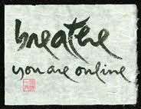
Healing Touch can make a positive change in your life.

Call 360-461-4538
to schedule an appointment.

